Geometry: Unit 1, Lesson 8

- A line segment is shown. What is the length of line segment $\overline{AC}$?
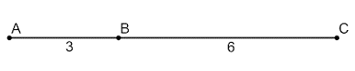

9 units

- A line segment, $\overline{WH}$, is shown, where $WB=7x+1$, $BH=4$, and $WH=5x+9$. What expression can be used to find the length of segment $\overline{WH}$.
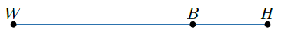

$$\left(7x+1\right)+4$$

- What is a part of a line that is bounded by exactly one endpoint?

Ray

